BIOS 731 Advanced Statistical Computing
Fall 2018
MCMC

# Metropolis

#bi-variate normal mean: mu1 = 0.mu2 = 0, correlation coefficient: rho = 0.6.
rho <- 0.9

# starting point
x0 <- 10
y0 <- 10

# length of chain
n <- 1000
x <- rep(0,n)
y <- rep(0,n)

# initialize
x[1] <- x0
y[1] <- y0

# tuning parameter
s0 <- 0.5 # maximum step size in random walk proposal function
# try different s0, e.g., 0.1, 1.0, 2.0

# start chain
for( i in 1:n) {
s <- s0*runif(1)
theta<-2*3.1415926*runif(1)
xnew <- x[i] + s*cos(theta) # random walk
ynew <- y[i] + s*sin(theta) # random walk
r <- exp(-((xnew^2-2*rho*xnew*ynew+ynew^2)-(x[i]^2- 2*rho*x[i]*y[i]+y[i]^2))/(2*(1-rho^2))) # acceptance ratio
test <- runif(1)
if(test < r ) # accept proposed moved.
{
x[i+1] <- xnew
y[i+1] <- ynew
}
else # reject proposed move, stay put.
{
x[i+1] <- x[i]
y[i+1] <- y[i]
}
}

# scatter plot
par(mfrow=c(2,2))
plot(x,y)
plot(x,y,type=”l”)
plot(x[101:1000],y[101:1000])
plot(x[501:1000],y[501:1000])
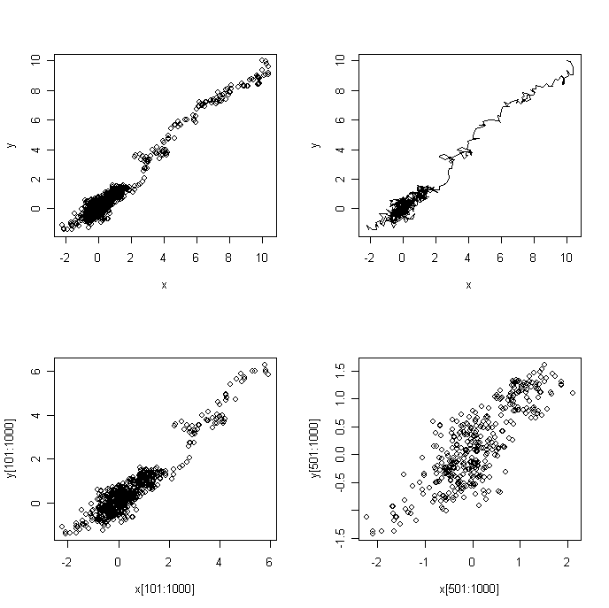

#trace plots
par(mfrow=c(2,2))
plot(x,type="l")
plot(y,type="l")

#autocorrelation plots
acf(x)
acf(y)
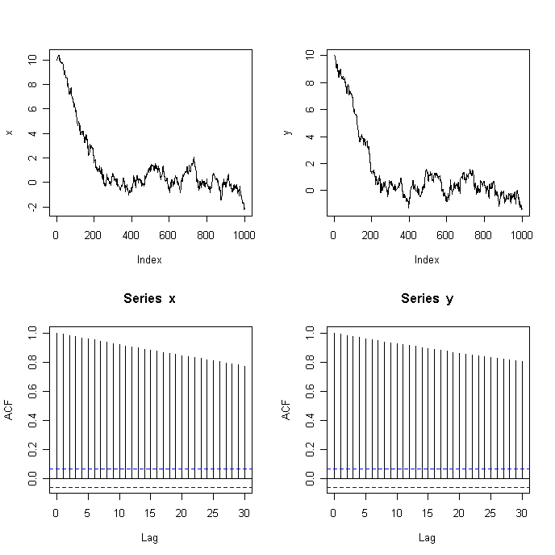
# Gibbs Sampler

# bi-variate normal, mean: mu1 = 0.mu2 = 0, correlation coefficient: rho = 0.6.
rho <- 0.6

# starting point
x0 <- 10
y0 <- 10

# length of chain
n <- 1000
x <- rep(0,n)
y <- rep(0,n)

# initialize
x[1] <- x0
y[1] <- y0

# start chain
for(i in 1:n) {
x[i+1] <- rnorm(1,rho*y[i],1-rho^2)
y[i+1] <- rnorm(1,rho*x[i+1],1-rho^2)
}

# scatter plot
par(mfrow=c(1,2))
plot(x,y,type="l")
plot(x[101:1000],y[101:1000])
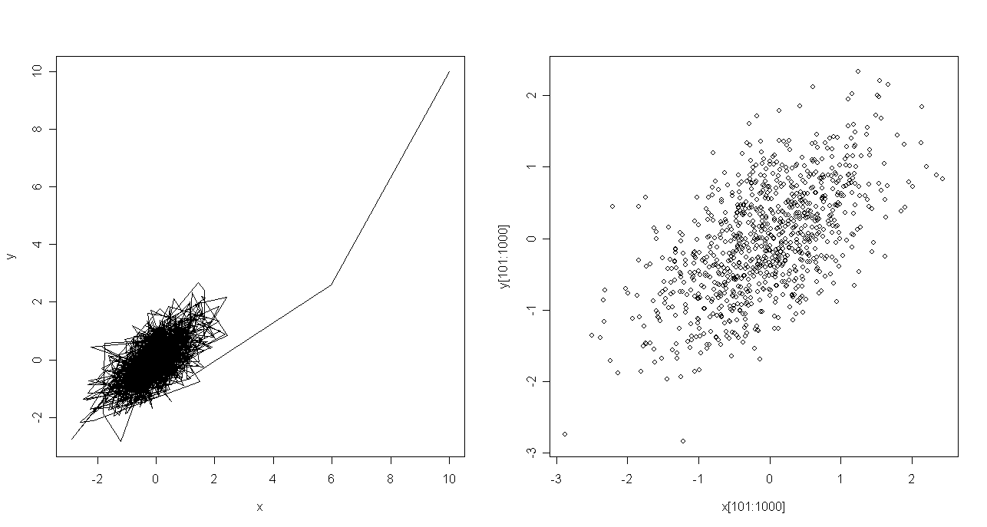

# trace plot
par(mfrow=c(2,2))
plot(x,type="l")
plot(y,type="l")

#autocorrelation plot
acf(x)
acf(y)
